

Name=Maryam Khan Minhas
Sap id=63024
Riphah International University
BS-Software Engineering -03

Practice task

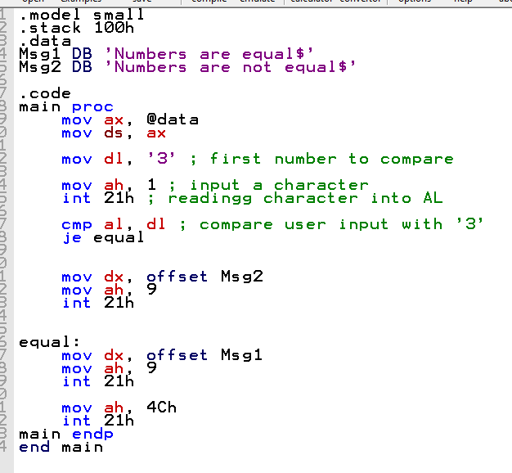

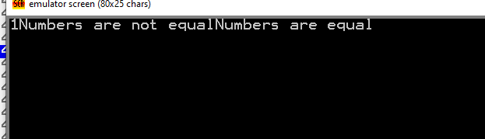

LAB task 1
Sum of first 10 numbers.

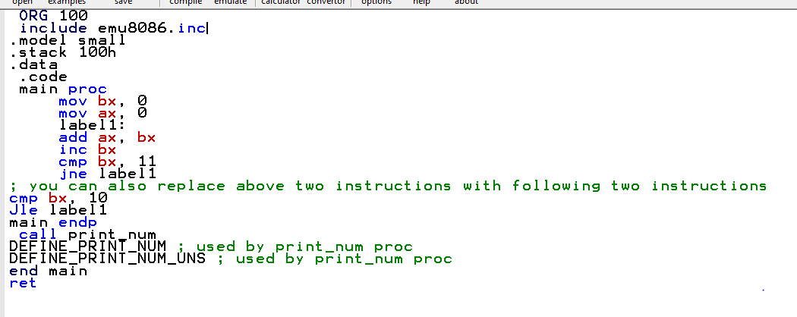

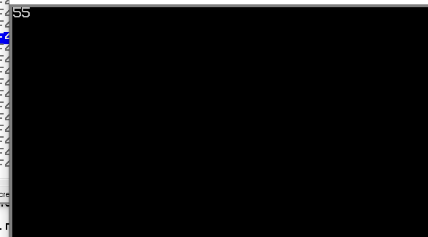

Lab task 2
Compare two numbers by taking input from user &jump to different sections of code to show
If number is equal,not equal,greater or smaller.